1. **Introduction**

*Testing Introduction:*

1. *Manual Testing*
   1. *Advantages*
   2. *Disadvantages*
   3. *M.T. Process*
2. *Automation Testing*
3. *Manual vs Automation Testing:*
4. **Manual Testing:**

Manual software testing is when human testers check the quality of a new application without using automation tools or scripting. The purpose is to identify bugs or defects, ensure the product is error-free, and check it conforms to specified functional requirements.

The process compares the behavior of a software application (or one of its components or features) with the expected behavior which was defined in the initial phases of the software development life cycle (SDLC).

Manual testers design test cases or scenarios with 100 percent test coverage, and execute them one by one before verifying the results. They ensure that any reported issues are passed to the development team to fix, and then tested again.

One of the fundamental principles of software testing is that 100 percent test automation is not possible—so manual testing is an essential part of your quality assurance process.

* 1. Advantages:

1.  Accurate

[Automated tools](https://www.globalapptesting.com/blog/automated-qa-testing) are smart, but they’re not as smart as humans. There are certain things that only a real person with real-world experience can spot. So when it comes to identifying bugs and glitches in software, manual testing is more likely to catch ’em all.

2.   Gives human insight

Manual software testers bring a valuable human perspective as well as accuracy, by focusing on the look and feel of a product. They can evaluate the application’s visual components and highlight UI and UX issues by adopting the mindset of the end user.

3.   Adaptable

The manual method is particularly useful in ad-hoc testing, as it’s easily adaptable when unplanned changes are made to software. The human input means test cases can be redesigned or tweaked with relative ease. Manual testing is also agile enough to be performed on all kinds of applications.

4.   Saves money

Although manual testing requires skilled labor, it can actually save your company money as it doesn’t need any expensive tools. Automation tools can be costly to install and will take time to set up and learn.

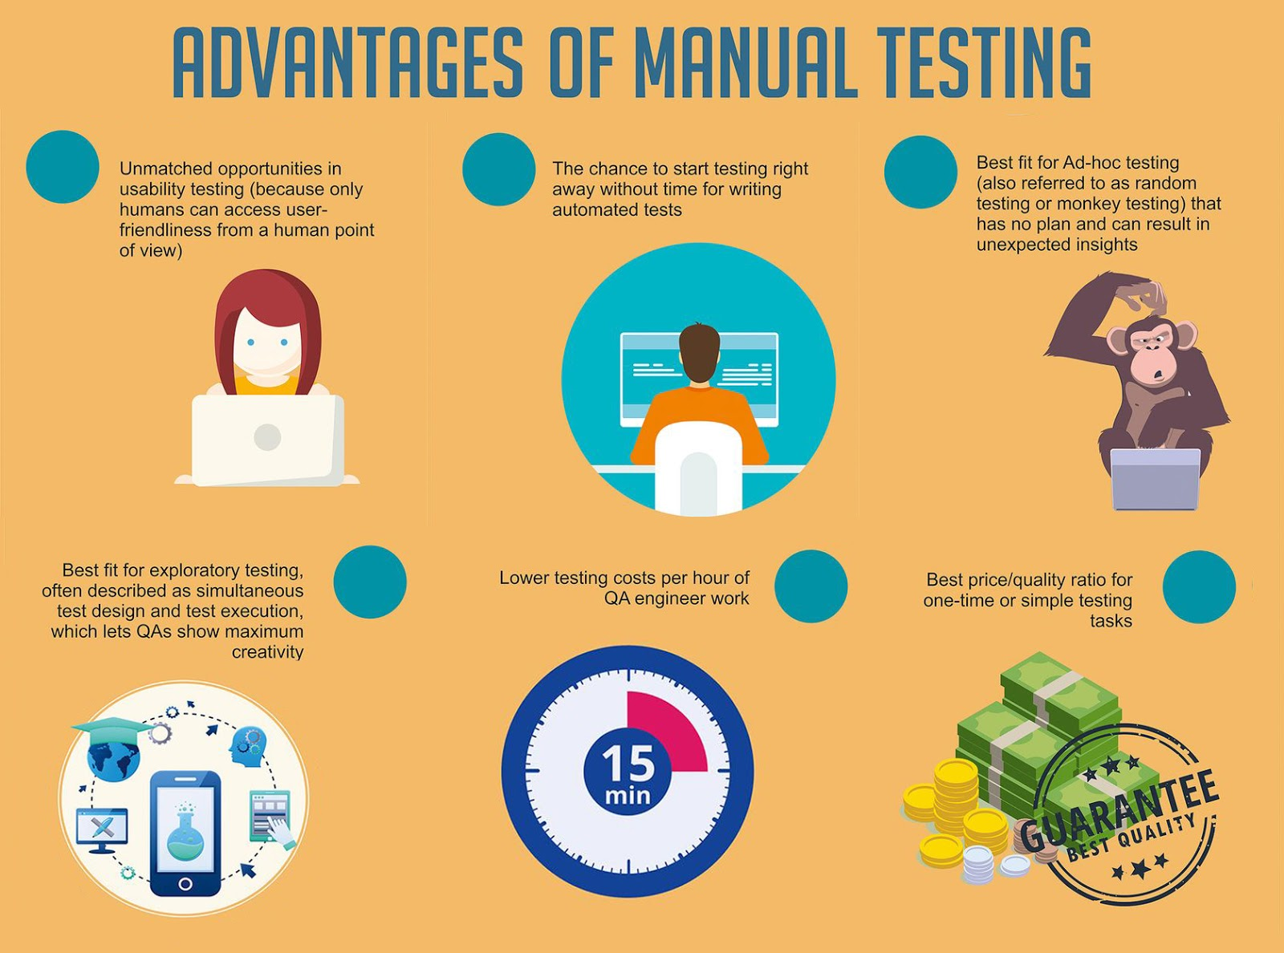

1.2. Disadvantages:

1.   Resource-heavy

Manual testing is undeniably more time-consuming than automation, which means the testing process is slower and can sometimes be more costly. It also requires a large number of human resources, with testers requiring high analytical and creative skills.

2.  Not always suitable

Certain types of testing, such as performance and load testing, are not suited to manual methods. For example, humans cannot simulate a large number of users for a performance test in the way a machine could. Large amounts of test data, too, are more efficiently handled by automation.

3.  Potential for error

This is the flipside to #1 in the “pros” column. Humans are smarter than machines in many ways, but they’re also prone to human error. Since manual testing is repetitive and boring, it’s possible for testers to lose concentration and miss something.

4.  Not reusable

As the manual testing process can't be recorded, manual tests are not reusable—you’ll need to develop separate test cases for each new application. It’s much easier to do this in automated testing where the scripts are reusable.

* 1. M.T Process

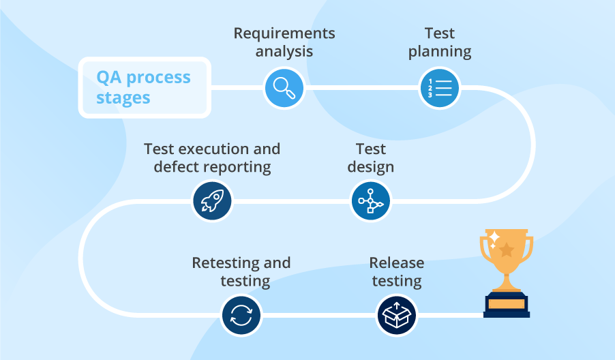

Defect Life Cycle:

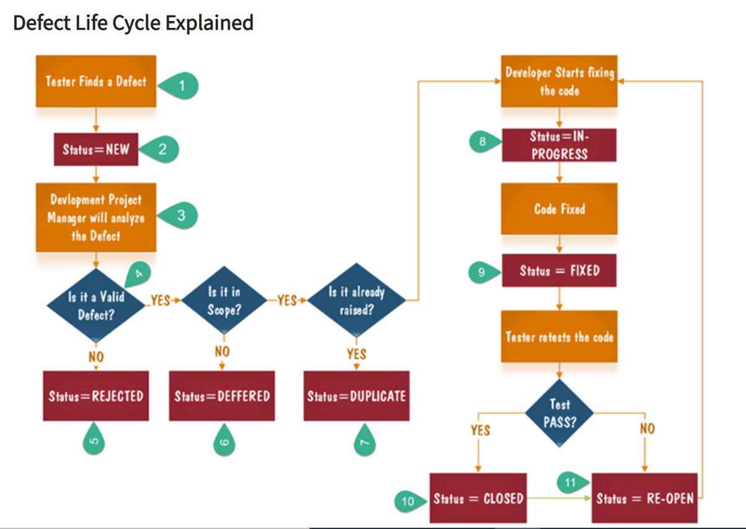

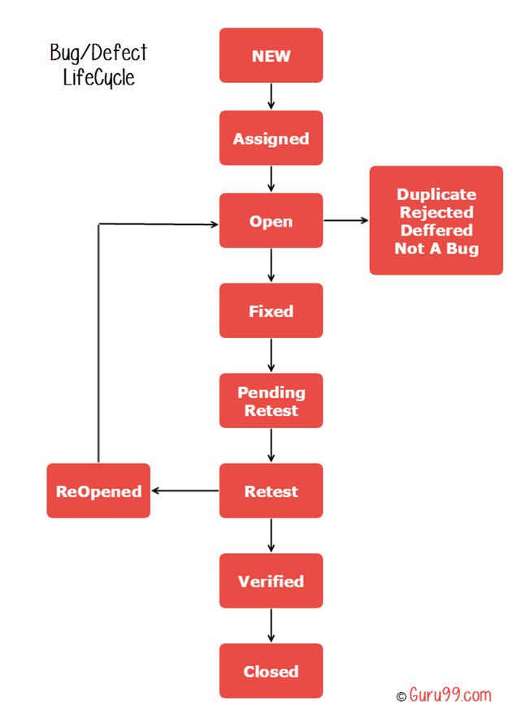

#### ****Evolution of Testing: From Manual to Automation Testing****

As the market’s dependency on technology grew, companies needed additional features to be shipped faster, to keep pace with different user needs and to stay ahead of the competition. Rapid development and adoption of Agile methodologies moved from being nice to have to must have.

Faster development cycles were introduced as a part of Agile methodologies that aimed to implement new features within a sprint that lasted a few weeks. However, while keeping the development cycles shorter, the time dedicated to software testing was reduced. This resulted in more bugs and a bad experience for users on less popular devices, who formed a long tail.

In a 2015 study by Statista, developers worldwide stated that in 32% of all software project failures, the leading reason was the insufficient time allocated to testing.

Although Manual testing performs well in areas that require quick early results and analysis, it does not yield fruitful results for testing areas, that require repeated iterations and execution of the code. It also cannot match up when the scale is huge, as it consumes time, and could end up causing unnecessary delays in a fast-moving technology space.

This is where [Automation Testing](https://www.browserstack.com/guide/automation-testing-tutorial) comes into the picture. The ability to run iterative, parallel tests on multiple devices, browser versions and operating systems in one go, with error logs and reports automatically generated, can easily be the difference between a market leader and a weak competitor.

**2. Automation Testing:**

Automation testing is a type of testing in which we take the help of tools (automation) to perform the testing. It is faster than manual testing because it is done by some automation tools. There is no chance of any human errors.

Testing is a vast landscape that consists of several categories like black box testing, white box testing, system testing, system integration testing, performance testing, and load testing. Some of these testing categories perform better with Automation, while others get desirable results with Manual Testing.

The key advantages of Automation Testing over Manual Testing are

* cost efficiency,
* easily perform testing at large scale,
* faster turnaround time, and
* better accuracy.

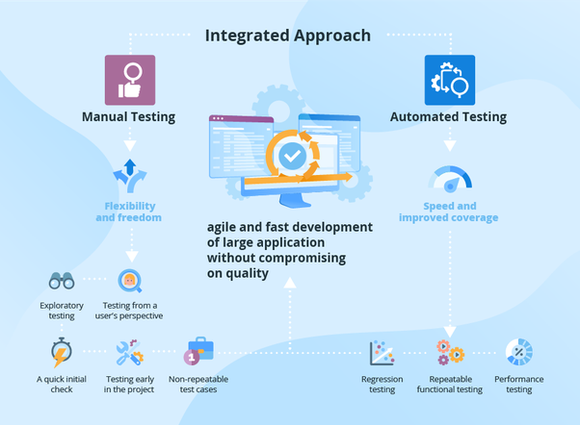

**3. Manual vs Automation Testing:**

|  |  |  |
| --- | --- | --- |
| **Criteria** | **Manual Testing** | **Automation Testing** |
| **Accuracy** | Manual Testing shows lower accuracy due to the higher possibilities of human errors. | Automation Testing depicts a higher accuracy due to computer-based testing eliminating the chances of errors |
| **Testing at Scale** | Manual Testing needs time when testing is needed at a large scale. | Automation Testing easily performs testing at a large scale with the utmost efficiency. |
| **Turnaround time** | Manual Testing takes more time to complete a cycle of testing, and thus the turnaround time is higher. | Automation Testing completes a cycle of testing within record time and thus the turnaround time is much lower. |
| **Cost Efficiency** | Manual Testing needs more cost as it involves the hiring of expert professionals to perform testing. | Automation Testing saves costs incurred as once the software infrastructure is integrated, it works for a long time. |
| **User Experience** | Manual Testing ensures a high-end User Experience to the end user of the software, as it requires human observation and cognitive abilities. | Automation Testing cannot guarantee a good User Experience since the machine lacks human observation and cognitive abilities. |
| **Areas of Specialization** | Manual Testing should be used to perform Exploratory Testing, Usability Testing and Ad-hoc Testing to exhibit the best results. | Automation Testing should be used to perform Regression Testing, Load Testing, Performance Testing and Repeated Execution for best results. |
| **User Skills** | Users must have the ability to mimic user behavior and build test plans to cover all the scenarios. | Users must be highly skilled at programming and scripting to build test cases and automate as |